NORFOLK COUNTY COUNCIL proposes to make a Temporary Traffic Regulation Order (STRO10541) affecting the C179 The Common from its junction with U78030 The Common for 80m westwards in the PARISH OF MULBARTON to facilitate BT works installing 2 new poles.

The road will be temporarily closed (except for access) between 08:30 and 15:30 on 29th April 2024 for the duration of the works expected to be about 8 hours within the period.

Alternative route is via: The Common, Norwich Road.

If necessary, the restriction could run for a maximum period of 18 months from the date of the Order.

Penalty: £1000 maximum fine on conviction and/or endorsement for contravention.

In the event of the start date being delayed the new start date will be displayed on site in advance.

The team dealing with enquiries at Norfolk County Council is South Area Streetworks (Community and Environmental Services Department) contactable by telephone at 0344 800 8020 or email at streetworks@norfolk.gov.uk. Details are also available at https://one.network.

Dated this 19th day of April 2024.

Katrina Hulatt
Director of Legal Services (nplaw)
County Hall
Martineau Lane
Norwich
NR1 2DH

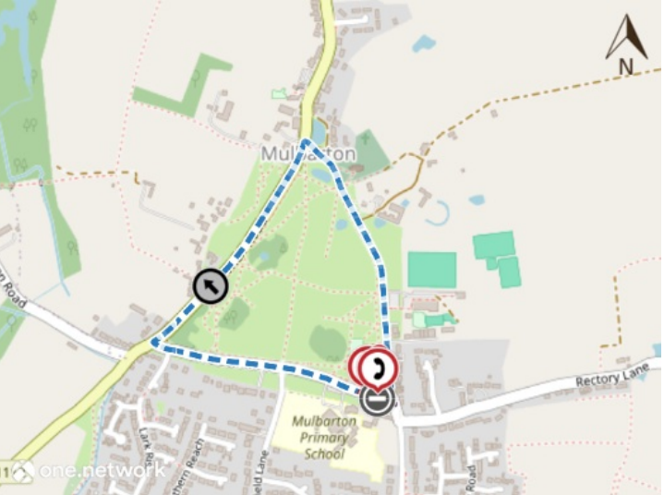
Imagery © 2023 MapTiler | Imagery © 2023 Hexagon | © MapTiler © OpenStreetMap contributors

