Norfolk County Council (Mulbarton)
(Emergency Notice)

Temporary Traffic Regulation Order 2024
Road Traffic Regulation Act, 1984 – Section 14(2)

Notice (STRO10752)

In accordance with the provisions of Section 14(2) of the Road Traffic Regulation Act 1984, the Norfolk County Council HEREBY GIVE NOTICE that owing to pipe repairs by Anglian Water the use by vehicles of the C179 East Carleton Road from its junction with B1113 Norwich Road for 50m northwards in the PARISH OF MULBARTON will be temporarily prohibited from 19th to 25th March 2024 for the duration of the works, expected to be about 7 days within the period.

This Notice has a maximum duration of 21 days. Where exceptional circumstances are encountered during the performance of the works specified in this Notice, the operational period of this Notice may become extended by issuing an Order or further Notice to allow completion of the works for a maximum duration of 18 months.

Alternative route is via: Norwich Road, East Carleton Road, Scotts Hill, Rectory Road, Wymondham Road, Water Tower Road, Cranes Road, The Street (Bracon Ash East Carleton, Mulbarton).

Penalty: £1000 maximum fine on conviction and/or endorsement for contravention.

The team dealing with enquiries at Norfolk County Council is South Area Streetworks (Community and Environmental Services Department) contactable by telephone at 0344 800 8020 or email at streetworks@norfolk.gov.uk. Details are also available at https://one.network.

Dated this 19th day of March 2024.

Katrina Hulatt
Director of Legal Services (nplaw)
County Hall
Martineau Lane
Norwich
NR1 2DH

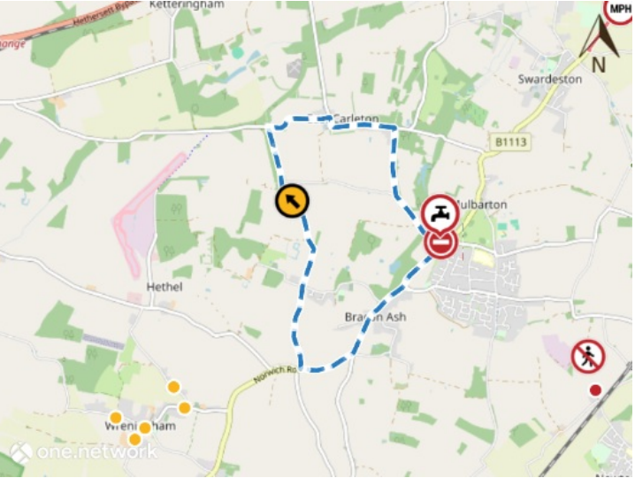
Imagery © 2023 MapTiler | Imagery © 2023 Hexagon | © MapTiler © OpenStreetMap contributors

